Flame Test Lab
Purpose:
TO determine what factor most influences the colors given off when different substances are tested with fire.
Background Information:
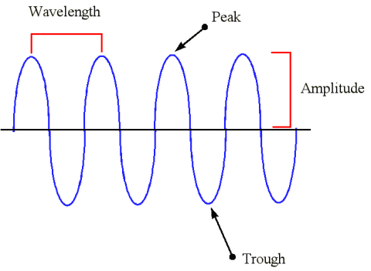
Light, a form of energy, is the fastest thing in the universe. At a speed of 3.0x10⁸ m/s, it can go around the Earth 7.5 times in one second! Light travels in waves of varying lengths, appropriately called wavelengths, and these wavelengths determine the color of objects we see around us. The various terms for wavelength are shown in the picture on the right. The wavelength (λ) is the distance between two peaks, or top of the wave. The amplitude is the height from the middle of the wave to the peak. And the trough is the bottom of the wave. Because light moves at varying wavelengths we are able to not only see different colors, like blue and red, but why we also have things like ultraviolet light, microwaves, and radio waves.
The spectrum goes Red, Orange, Yellow, Green, Blue, Indigo and Violet (or ROY G. BIV). In the light spectrum there is a relationship between its wavelength and frequency. On the red side of the spectrum below, you can see it says long wavelength, low frequency.. This means that because the wavelength is longer for red, it does not appear as often, so the frequency is low. On the other hand, because violet has a shorter wavelength, the frequency is higher. The wavelengths (λ) in this case are measured in nm, or nanometers. 1 meter is equal to 1x10⁹ nm.
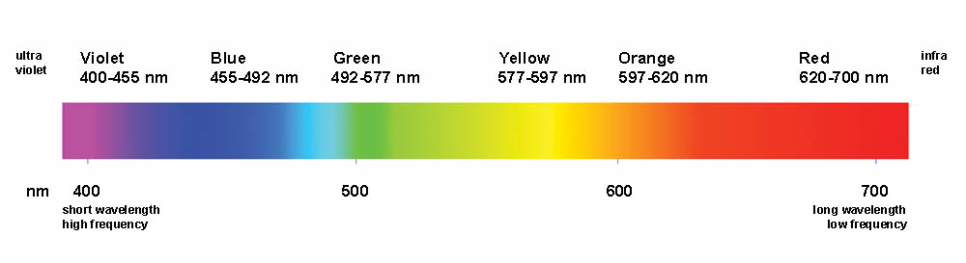
The mathematical formula that relates wavelength and frequency is λ = c/v. Where λ (lambda) represents wavelength, c represents speed of light, and v represents frequency. [Remember, λ is given in nanometers, and the speed of light is in meters per second.]
Procedure:
- Set up Bunsen burner. Person 1 uses flint to light the match. Person 2 turns on gas, while Person 1 places lit match atop the Bunsen burner. The burner should light up.
- Obtain a flame test loop, along with your necessary chemicals in your chemical wells. 10 drops of each chemical. You will also need HCl in a small beaker.
- Dip the wire loop into the HCl. You must do this after EVERY flame test to clean off any residue from the previous tests.
- Burn all the liquid off the wire.
- Test each chemical, one at a time, recording your observations and cleaning the loop after every flame test.
- When you have finished, obtain your two unknown chemicals and repeat Step 5.
Pre-Laboratory Questions:
- What is the speed of light? What property does light have that allows us to see different colors?

- What color light is emitted if it has a wavelength of 540 nm? Convert this wavelength into meters.
- How are frequency of light and wavelength related?

- What is the purpose of HCl in this experiment? Because we are working with HCl, Hydrochloric Acid, what safety precautions do we need?

Data Table:
Compound Formula | Sample Color (before lighting) | Flame Color (first color you see) | Estimated Wavelength (nm) | Converted Wavelength (m) | Frequency  v = c/λ

Post-Laboratory Questions:
- What visible patterns could you pick up on during this experiment? How did these patterns help you figure out what your unknown substances were?

- What do you think determines the color of the compound, the metal or the non-metal? How do you know?

- Given our data, if a scientist wants to make aqua or blue fireworks, what metal do you think he should be using? How do you know?

- Calcium emits a light of 573.2 nm. What is its frequency?

- What errors do you think could arise from doing this experiment? (hint: what is the purpose of the HCl)

