The “Full Metal Alchemist” Penny Lab

**Introduction**:

The modern practice of chemistry started with the study of alchemy in medieval Europe and the Middle East. Alchemists believed that by doing certain chemical reactions, you could turn cheap, inexpensive metals into gold. Often, alchemists would convince people that they could do this and sell them the “secret” procedure.

In this lab, you will have an opportunity to be an alchemist, only you have the advantage of knowing the difference gold and something that looks like gold. In this experiment you will be transforming a penny (mostly made out of the element Copper – Cu) into a “gold” penny. This process is called galvanization – the chemical process of combining two or more metals together to form an alloy. Galvanizing metals can profoundly change both the chemical properties and, more obviously, the physical properties of the metal, including a copper penny.

**Purpose:**

In this lab you will be working with a copper penny, allowing you to examine the difference between an element and a compound, along with seeing the difference between a physical and a chemical change, while trying to make this penny turn gold.

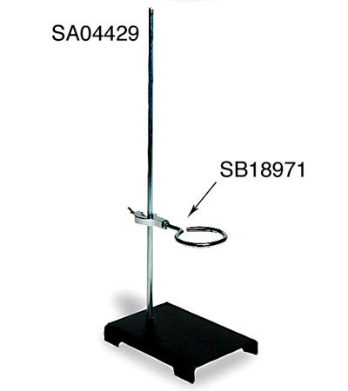**Materials**:

* 1 copper penny
* 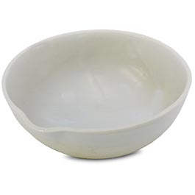Electronic balance
* Hydrochloric acid solution (HCl)
* Tongs
* Granular zinc (Zn)
* **Evaporating dish**
* Graduated cylinder
* Sodium hydroxide solution (NaOH)
* Wire gauze
* **Ring clamp**
* **Ring stand**
* Bunsen burner

**Safety:**

In this lab, it is very important that you wear your goggles at all times. The chemicals that we are working with are extremely dangerous, and can cause serious injury if an accident occurs!

**Procedure:**

1. Obtain 1 penny. Take the penny and go to the electronic balance. Press the tare/zero button to make sure the balance reads 0.00 g. Take the mass of the penny and record in your data section.
2. Pace the copper penny in a solution of HCl (hydrochloric acid) for 1 to 2 minutes. Use enough of the acid to cover the penny. Observe any chemical reactions that occur.
3. Remove the penny with tongs and rinse with water. Dry with a paper towel but do not touch the penny with your hands. Place the penny on your lab bench.
4. Use the balance to add approximately 1.0 g of granular zinc to an evaporating dish (*don’t forget to tare/zero the balance first*!).
5. Use a graduated cylinder to measure approximately 20 mL of NaOH solution. Add the solution to the evaporating dish. Finally, place the penny in the dish.
6. Place the evaporating dish on a piece of wire gauze. Place the dish and the wire gauze on a ring clamp supported by a ring stand.
7. Light a Bunsen burner and use it to gently heat the dish. Continue to heat the penny until it is completely covered with zinc (about 5 to 10 minutes). Observe its physical appearance and any changes it undergoes.
8. Use the tongs to remove the penny from the solution. Place the penny in a small amount of water for approximately 30 seconds. Remove the penny and dry it with a paper towel.
9. With the crucible tongs, gently heat the penny directly over the Bunsen burner until you observe a color change. Once the color has changed, remove the penny from the heat and let it cool on the lab bench.

**Hypothesis:**

In this lab we will be fusing zinc with a (mostly) copper penny. Do you think the penny is going to be going through a physical or chemical change? Additionally, what do you think will happen to the physical properties about the penny (size, shape, color, texture, etc)?

**Pre-Laboratory Questions:**

1. In Procedure step #1, it asks you to make sure to press the tare/zero button on the electronic balance. Why is this a necessary step before finding the mass of the penny?
2. Since we are working with a very strong base in our experiment (NaOH), what two safety precautions are absolutely necessary? Why are these precautions necessary?
3. What is galvanization? Describe how this process works, and what the eventual outcome is.
4. In this lab, what two metals are being galvanized?
5. Is galvanization a chemical or a physical process? How do you know?

**Data and Observations**:

1. Mass of the penny: _____________________ g
2. Observation of the penny when it is placed in hydrochloric acid (HCl)
3. Observation of the penny when it is heated in a solution of NaOH and Zn.
4. Observation of the penny after it is heated in the Bunsen burner.

**Post Laboratory Questions**

1. For the following:
   1. Convert the mass of the penny to mg. ____________ ___
   2. Then write the mass in mg in scientific notation. __________________.
   3. The volume of NaOH used in this lab is 20.0 mL. Convert this volume to kL. ___________________.
   4. Write the volume in kL in scientific notation. ___________________
2. Classify each of the following as an element, compound, homogeneous mixture, or heterogeneous mixture:
3. Copper (Cu) ______________
4. Zinc (Zn) ____________
5. Sodium hydroxide solution (solid NaOH combined with water) _________________
6. The penny after it is heated in the Bunsen burner __________________
7. Agree or disagree with this statement with an explanation: “Heating the penny in the Bunsen burner flame caused it to change into a gold penny.”