Name:
Period:
Orbital Notation Homework
- Who was Niels Bohr, and what did he think an atom looked like?

- Draw a picture of what Bohr thought an atom looked like (an electron configuration) – use Silicon as your example element.

- How do electrons actually move around the nucleus? What are these “rings” called?

- Give three examples of orbitals and draw them.

- In this example, n = 2. What does n represent? What does the two represent? Give an example of an element in n = 2.

- Identify on this blank periodic table which sections are S, P, D and F orbital regions. Also include the periods (using n = 1, 2, 3, etc.) to the left of the Periodic Table provided.
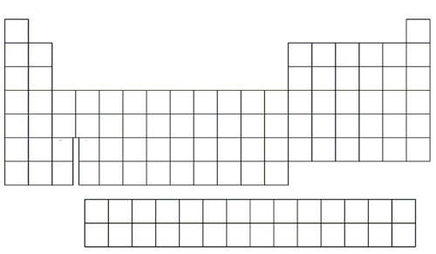
- Write the orbital notations for each of the following elements:
Helium Carbon Sulfur Potassium
Beryllium Oxygen Magnesium Argon

- Discover the element using the given orbital notations:
1s²2s²2p¹ 1s²2s²2p⁶ 1s²2s²2p⁶3s²3p¹ 1s²2s²2p⁶3s²3p⁵
1s¹ 1s²2s²2p¹ 1s²2s²2p⁶3s¹ 1s²2s²2p⁶3s²3p⁶4s²

- Challenge: Identify the following elements using the given orbital notations:
1s²2s²2p⁶3s²3p⁶4s²3d¹⁰4p⁶5s²4d⁵ [Kr] 5s²4d¹⁰5p⁵ [Xe] 6s²5d¹4f¹²
Name:
Period:
Orbital Notation Homework 2
- In this example, n = 4, ℓ = 1. What does n represent? What does the four represent? What does ℓ represent? What does the 1 represent? Give an example of an element in n = 4, ℓ =1?

- Review: Write the orbital notation for each of the following (Row, Section, Seat #)
Neon Magnesium Sulfur Calcium

- Review: Write the orbital notation for each of the following:
1s²2s² 1s²2s²2p³ 1s²2s²2p⁶3s² 1s²2s²2p⁶3s²3p⁶

- Explain the three major quantum principles discussed in class.

- Find Gallium on your periodic table
Row (n = ): Section (S,P,D,F): Seat #:
Write the Orbital Notation for Gallium (remember: D-section = n-1):

- Name all of the Noble Gasses:

- Write the NOBLE GAS NOTATION for each of the following (remember: D-section = n – 1):
Chromium Germanium Strontium Iodine
Aluminum Zinc Ruthenium Barium

- Identify the elements described using NOBLE GAS NOTATION:
[Ar] 4s² [Ar] 4s²3d⁹ [Ar] 4s²3d¹⁰4p³
[Kr] 5s¹ [Kr] 5s²4d³ [Xe] 6s¹

- Find Ytterbium on your periodic table
Row (remember: F-section = n-2): Section: Seat #
Write the NOBLE GAS NOTATION for Ytterbium (remember: F-section = n-2):

- Write the NOBLE GAS NOTATION for each of the following (remember: D-section n-1; F-section n-2)
Yttrium Tantalum Europium Bismuth
Francium Curium Lawrencium Mercury

- Identify the elements described using NOBLE GAS NOTATION:
[Xe] 6s²5d¹4f³ [Xe] 6s²4f¹⁴5d³ [Xe] 6s²4f¹⁴5d¹⁰6p²
[Rn] 7s² [Rn] 7s26d¹5f¹² [Rn] 7s²5f¹⁴6d⁴

