Pesticide and Erosion Homework
- Use the information below to answer the following questions
Year | 1880 | 1900 | 1920 | 1940 | 1960 | 1980 | 2000 | 2020 | 2040
Organophosphate  (million kg) | 5 | 12 | 18 | 23 | 43 | 65 | 86 | ? | ?
# Weed Species | 230 | 43 | 22 | 156 | 356 | 503 | 1030 | ? | ?
- Draw a graph using the information above. You will need to Y-axes for this graph. Label your graph appropriately.

- Give an example of an organophosphate pesticide that is common in the US. What type is it? What does this mean?

- From the years 1880 to 1920, what appears to be the relationship between the pesticide use and the number of weed species? Why does this trend happen?

- From the years 1940 to 2000, what appears to be relationship between the pesticide and the number of weed species? Why does this trend happen?

- Although the years 2020 and 2040 have not yet occurred, what do you think will happen in those years, if these uses continue? How do you think this will impact the environment (give two possible outcomes)?

- What is the pesticide treadmill? How does it apply to the data shown in your graph in Part A?

- After World War II, DDT was the most commonly used pesticide. However it was discontinued in the late 1960’s.
  - What type of pesticide is DDT?

  - In her book, Silent Spring, what did Rachel Carson reveal about DDT?

  - What is biomagnification, and how does it relate to DDT? Use an actual example of this occurring.
  - DDT is very similar, property-wise, to CFCs (discussed in a previous chapter relating to the ozone layer). Use two reasons to explain how the two are similar.

  - What is the Grasshopper Effect? Discuss the environmental implications of this effect, relating it to DDT.

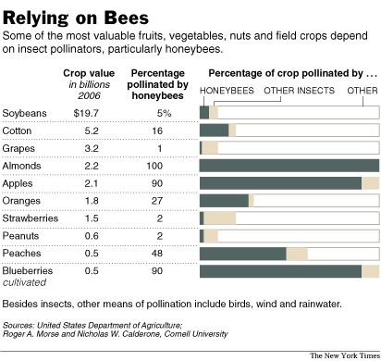
- The honey bee population has experienced a significant decline in recent years, and scientists have linked it to pesticide usage.
  - Looking at the table, which crops will be most heavily affected by the declining bee population?

  - How do you think this will affect crop yields of these particular items in future years? What will that do to prices? How do you know this?

  - What kinds of health effects do pesticides have on humans?

  - What solutions should be proposed, instead of relying too heavily on pesticide use (name and briefly explain three possible solutions).

- Soil erosion has become a big problem in farms across the world, particularly in the United States, where there is more soil erosion than anywhere else in the world.
  - What are the four major components of soil? Represent them in a soil texture triangle.

  - Describe how the soil in a grassland differs from that of a desert, and that of a forest. Which biome has the most fertile soil, and why?

  - What is erosion? What are the two biggest contributors to erosion?

  - Briefly explain the three major forms of erosion, and the two negative effects of erosion that can happen.

