Phase Diagrams and Heat with Phase Change Homework

Given information for H₂O:
ΔH_{fus} = 6.01 kJ/mol Melting Point: 0.00ºC
ΔH_{vap} = 40.7 kJ/mol Boiling Point: 100ºC
C = 4.18 J/ºC•g
- How many kilojoules (kJ) are required to heat 250 grams of liquid water from 0⁰C to 100⁰ C?

- How many kilojoules (kJ) are required to melt 100 grams of water?

- How many kilojoules (kJ) are required to boil 150 grams of water?

- How many kilojoules (kJ) are required to heat 200 grams of water from 25 ˚C to 125˚C?

- How many kilojoules (kJ) are given off when 120 grams of water are cooled from 25˚C to -25˚C?

- How many kilojoules (kJ) are required to heat 75 grams of water from -85˚C to 185˚C?

- How many kilojoules (kJ) are required to heat a frozen can of juice, mostly water (360 grams) from -5 ˚C (the temperature of an overcooled refrigerator) to 110˚C (the highest practical temperature within a microwave oven)?

- Label all of the components (a, b and c). Include all of the necessary numbers, and the type of reaction that is occurring. Additionally, show what would happen if a catalyst was put into this reaction.
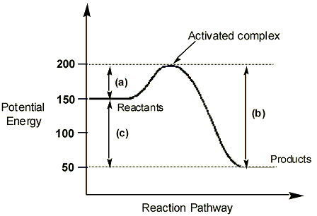
a

