Population Growth Math Homework
Show all of your work for the following, trying not to use a calculator.
- If a country has a crude birth rate of 24 per 1,000 and a crude death rate of 8 per 1,000, calculate the annual percent increase of its population.

- If a city of population 10,000 experiences 100 births, 40 deaths, 10 immigrants and 30 emigrants in the course of a year, what is its net annual percentage growth rate?

- Based on the data table below, construct an age-structure diagram, and explain how you can tell what type of nation the data:
Age Range | 0-9 | 10-19 | 20-29 | 30-39 | 40-49 | 50-59 | 60-69 | 70-79 | 80+
% Male | 5 | 7 | 8 | 11 | 12 | 15 | 14 | 15 | 13
% Female | 6 | 9 | 9 | 11 | 11 | 13 | 15 | 16 | 10

- 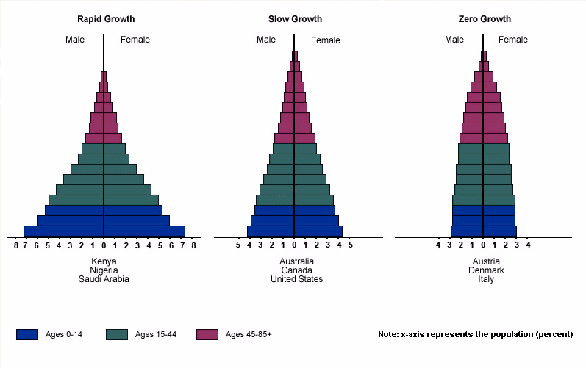
  - Which country of the above age structure diagrams would experience RAPID population growth? Explain why.

  - Looking at the third country, what percentage of the population is under age 15?

- Use the data table below to answer the following questions, show your work:
Country | Population  (millions) | Approx. Land Area  (million km²) | Total Electricity Usage  (10¹⁰ kWh)
Australia | 19.7 | 8.2 | 22
Bangladesh | 144 | 0.14 | 1.6
China | 1,295 | 9.6 | 150
Ethiopia | 70 | 1.12 | 0.20
India | 1,000 | 3.29 | 60
United States | 300 | 9.63 | 400
- Which country has the highest population density? Show your work.

- Which country has a population about three times that of the United States (show your work)

- On an annual basis, the per capita electricity usage in Ethiopia is approximately what percent of the per capita electricity usage in the United States?

- The country of Sudan has an estimated annual growth rate of 2 percent. At this rate of growth, approximately how many years would it take for the population of Sudan to double? (given: ln (2) = 0.7)

- In 2003, the global human population was at about 6.1 billion people, growing at an annual rate of 1.35 percent. If the world population were to grow at this rate for the next year, approximately how many people would be added (rounding your answer to the nearest whole number)?

- If the population of a country grows at a rate of approximately 5 percent per year, the number of years required for the population to double is closest to how many years? (given: ln (2) = 0.7)

