Titrations Lab
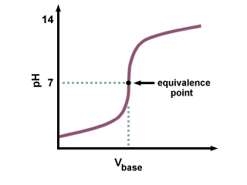
Introduction: Titrations involve adding a basic solution to an acid. Since bases have a high pH, when they come in contact with an acid, the pH of the acid will increase. Over time if more of the base is added, the acid will turn into a base. The point at which this happens is called the equivalence point (shown below). In order for a titration to occur, you will use a buret filled with the base, shown below:
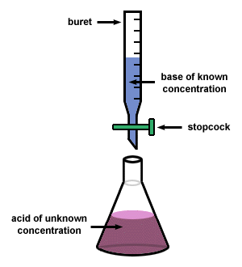

You will be able to detect this change from an acid to a base using a color indicator, phenolphthalein. When the solution has reached its equivalence point, the solution will turn LIGHT PINK. If the solution has gone too far (too basic) it will turn DARK PINK.
NOTE: The acids and bases we are working with are CORROSIVE (they can burn you). Safety goggles must be worn at all times as a result.
Materials: Ring Stand, Graduated Cylinder, Funnel, Buret, Flask, 0.1M NaOH solution, HCl solution, Safety Goggles
Procedure:
- Fasten the buret onto the clamp securely, be sure that it does not move around.
- If it isn’t already done, turn the stopper so that it is sideways. Fill the buret with 0.1M NaOH solution up until around 0 mL with the help of a funnel.
- Fill the graduated cylinder up with 50mL of HCl solution, and pour it into the flask
- Add two drops of phenolphthalein to the flask of HCl.
- Set up the flask underneath the buret. DO NOT LET THE BURET TOUCH THE FLASK!
- Release the stopper (it will be up and down) so the 0.1 M NaOH solution will start to flow into the flask.
- As the NaOH solution flows, have one person in your group GENTLY swirl the flask. Over time the acid will start to turn pink and then go away.
- When you begin to see pink, slow down the speed by turning the stopper more sideways. Keep swirling.
- When the pink is seen for longer periods of time, turn the stopper sideways, go DROP by DROP.
- When the solution turns light pink, you are done. Record the volume of NaOH you use.
- Dump and rinse the flask with the pink solution. Refill the buret with NaOH and start again. You will do this three times.
Pre-Laboratory Questions:
- What does it mean to “titrate” something?
- What is the equivalence point?
- In this lab we are using NaOH and HCl. Which is our acid? Which is our base? How do you know?
- What will be using to figure out what color the solution will turn?
- How do you know the solution has reached its equivalence point? How do you know you’ve gone too far?
- We need to wear safety goggles in this experiment. Why?
Data and Observations:
- Record the STARTING VOLUME and ENDING VOLUME of your buret using the table provided below. You will draw your own tables on your lab sheet.
Trial | Starting  Volume (mL) | Ending  Volume (mL) | Difference  (Ending – Initial)
1
2
3
Average | To find the average, ADD the three differences and then DIVIDE by 3.

- Using the formula: M₁V₁ = M₂V₂. Find the concentration (M) of your acid, HCl. To find it, your M₁ is the concentration of your base (NaOH) given to you, your V₁ is the AVERAGE you just found in the table above. Your V₂ is the amount of HCl you added to your flask (50mL). Find your M₂. SHOW YOUR WORK.

- Now that you have M₂, use this and your volume of 50mL (0.05L) to find the MOLES of HCl you use (M = mol/L).

- Convert this into GRAMS of HCl you use (1 mol HCl = 36 grams HCl)

Post-Laboratory Questions:
- What was the concentration of your acid? How does it compare to the concentration of your base (0.1M)…is it higher or lower?
- Given your answer in number 1, which do you think is stronger, HCl or NaOH? How do you know?
- As you added more base to the solution, what did you notice happened to the color of your flask? Why is this happening?
- Why do you think swirling the solution was important? What happened
- Draw what an equivalence point looks like on a mini-graph. What color of the flask indicates that you have reached your equivalence point? What if you have gone too far? What color did your flasks look like?
- Was there any trial where you got a difference that was very strange compared to the other two? What do you think could have gone wrong?

