**Topography Activity**

**Vocabulary**: Define the following terms:

* topography –
* elevation -
* bench mark -
* contour line -
* contour line interval -

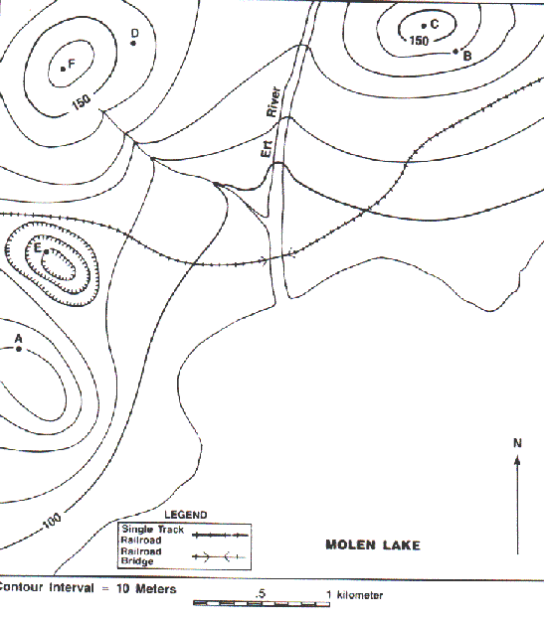

Questions:

1. What is the exact elevation of the following points?

        a. point A = _____ meters        b. point E = _____ meters

2. What is the approximate elevation of the following points?

        a. point C = _____ meters        b. point F = _____ meters

3. Explain why you can determine the exact elevation for points A and E but only approximate elevations for points C and F.

4. How many hills are shown on the map? What letters are they? How high are they?

5. In which direction is the Ert River flowing? How do you know?

6. Which of the following points have the same elevation?

        a. points A & B        b. points E & A        c. points C & D        d. points F & C

7. Draw an island approximately 1.5 km long and 1.0 km wide.  Draw it in Molen Lake so that its longest dimension runs approximately north-south.

8. Add a mountain with elevation between 120 to 130 meters to the northern end of the island.  Draw a lake on top of the mountain with a river flowing out of it in an easterly direction.

9. Add another mountain that has a depression on its top that is between 10 and 20 meters deep on the southern end of the island.

10. Label all contour lines on the island in meters.

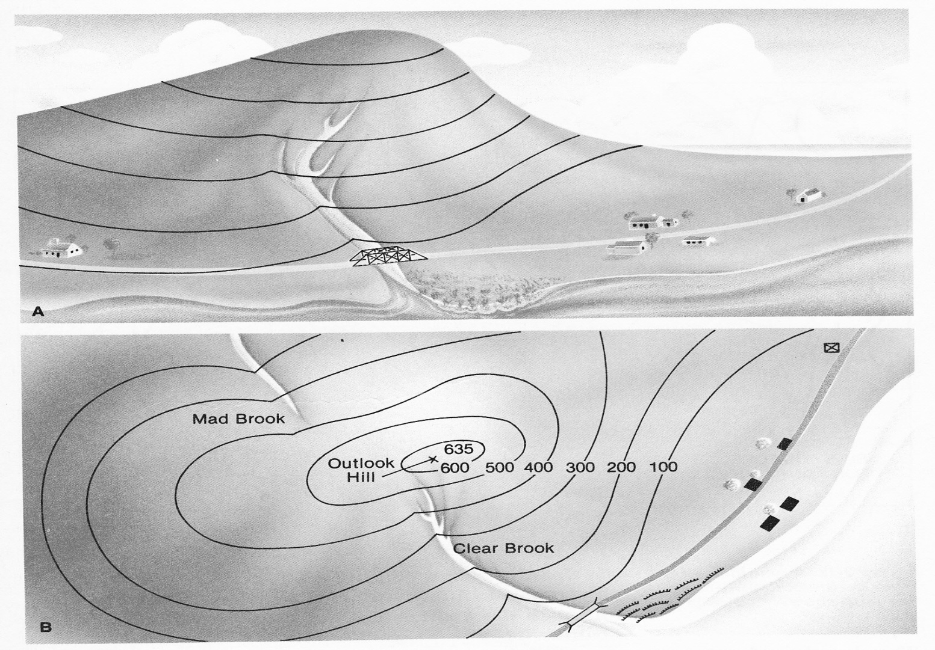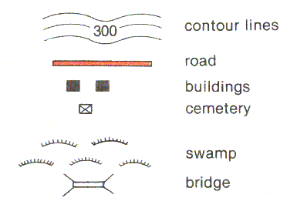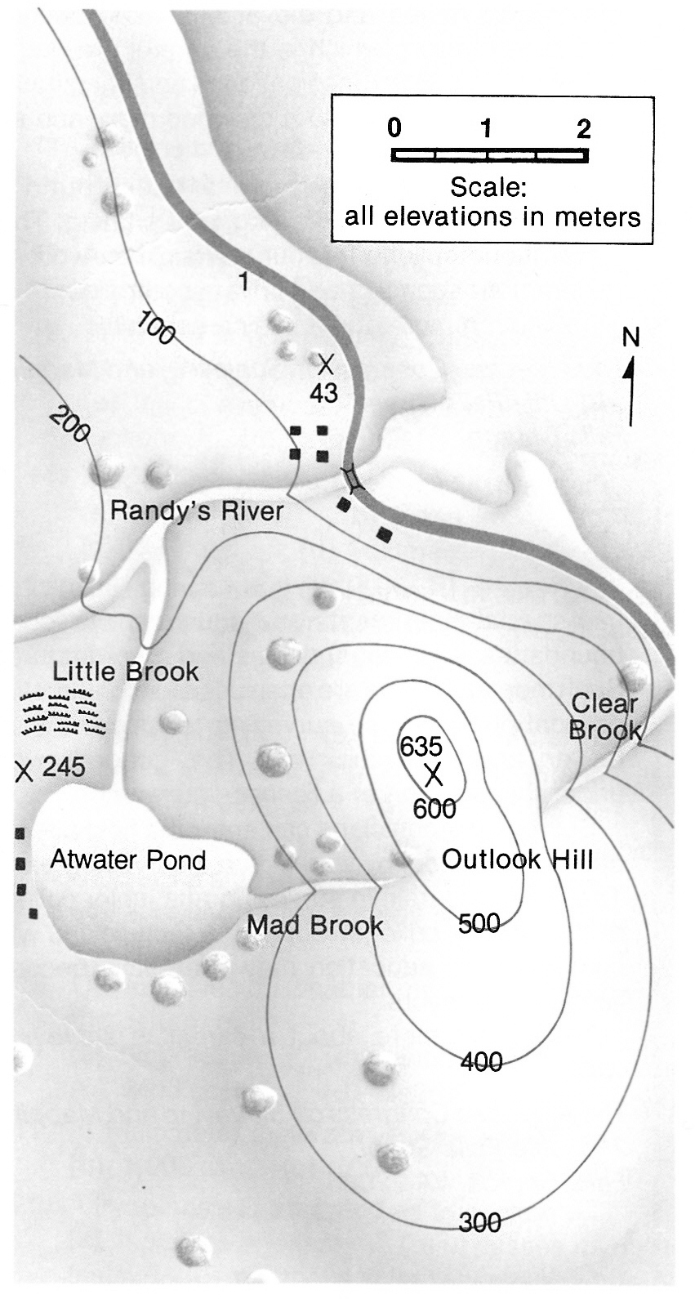**Topography Activity #2**QUESTIONS:

1. What is the highest elevation on the map?  What is the lowest elevation?
2. How many bench marks are there on the map?  What elevations do they mark?
3. What is the contour interval? _____________________
4. What is the highest contour line?__________________
5. Why are the contour lines closer together on one side of Outlook Hill?
6. In what directions do you find steep slopes on the map? How do you know they are steep?
7. Imagine you are traveling south on Route 1 (in red).  Describe the landscape and its changes as you travel along.
8. Study the brooks and rivers.  In which direction is each flowing? How do you know?
9. Find Outlook Hill.  Which is its steepest side?  Draw a side view of the hill as seen from Clear Brook.
10. Describe the scenery you would see if you traveled around Atwater Pond in a boat.
11. Which stream flows into Atwater Pond?  Which stream flows out of Atwater Pond?  How can you tell?
12. How many buildings are shown on the map? __________
13. Where is the swamp located?  Be sure to state direction in regards to location of swamp relative to nearby terrain.
14. What is the length of Route 1 on this map? ____________________
15. How far is it from the buildings on Route 1 to Atwater Pond?  In what direction would one walk to get there?

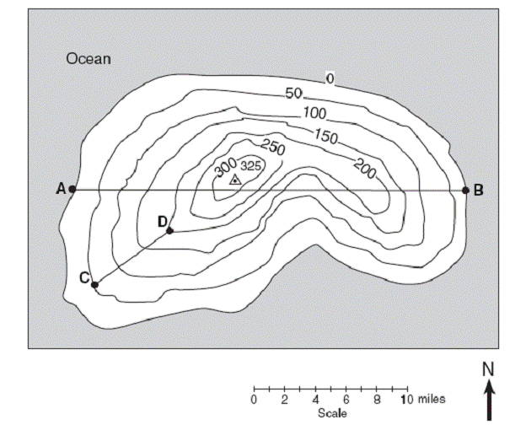**Topography Activity #3**

**Questions**:

1. What is the contour interval of this map? __________
2. What is the highest elevation? __________  Lowest elevation? __________
3. Measure the distance, in centimeters, from Point A to Point B. __________
4. Convert this distance into miles using the scale provided below the map: __________
5. Repeat numbers 3 and 4 for Point C to Point D.

cm distance: __________     miles: __________

1. Determine the elevation at Point C: __________ and Point D: __________ Difference (D-C): __________
2. Calculate the elevation gradient between Point C and Point D: __________

gradient = difference in field values ÷ distance between points

1. Draw a profile that describes the elevation across line A-B. Have miles in the X-axis and Height (meters) in the Y-axis. Be as accurate as possible.

|  |
| --- |
|  |
|  |
|  |
|  |
|  |
|  |
|  |
|  |
|  |
|  |
|  |
|  |
|  |

1. Draw a profile that describes the elevation across line C-D. Have miles in the X-axis and Height (meters) in the Y-axis. Be as accurate as possible.

|  |
| --- |
|  |
|  |
|  |
|  |
|  |
|  |
|  |
|  |
|  |
|  |
|  |
|  |